# 4CS017 – Internet Software Architecture tutorial

## Performance testing

*What will you learn today?*

You will learn to test the performance of your web app using Chrome’s standard dev tools and Lighthouse tools.

## Part 1 – The dev Tools Network tab

First, simply **time** your HTTP requests, and measure the overall load time of your web app using the “Network” tab.

1. Load both your Prototype 1 and Prototype 2 and note the “Finish” value at the bottom.

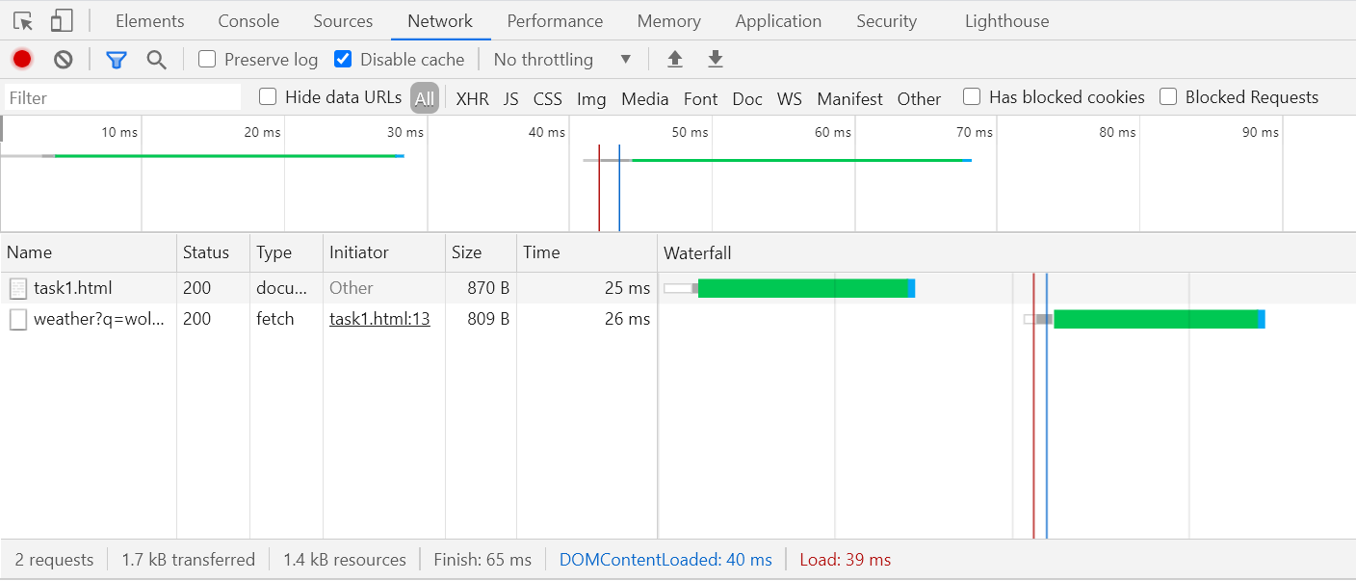

1. Reflect on the values. Have you gained anything? Consider using your findings in your report for prototype 2 and later prototype 3.

## Part 2 – Google Lighthouse

“Lighthouse is an open-source, automated tool for improving the quality of web pages. You can run it against any web page, public or requiring authentication. It has audits for performance, accessibility, progressive web apps, SEO and more.” ([source](https://developers.google.com/web/tools/lighthouse))

1. Run Lighthouse against your prototype 2, like this:

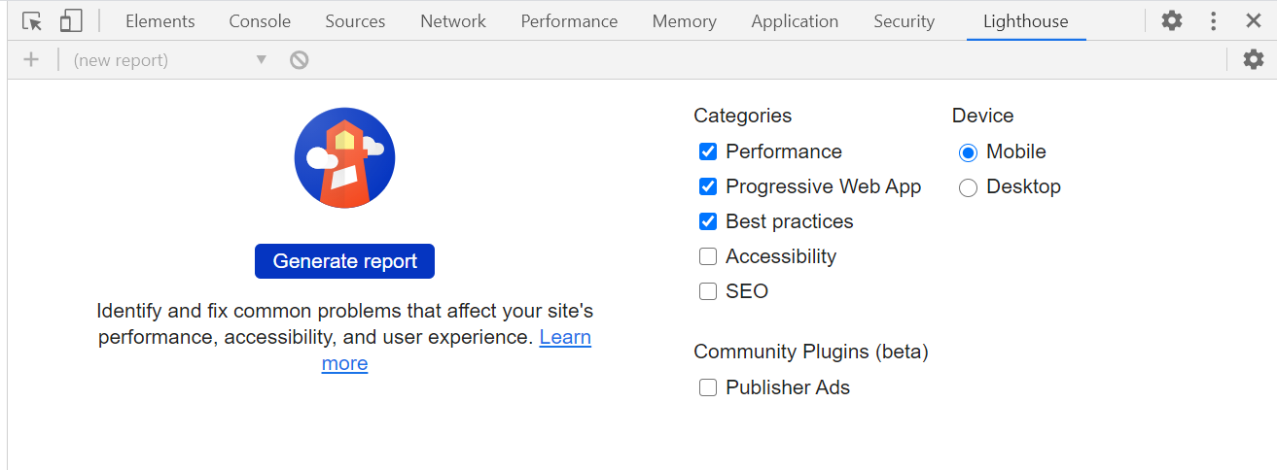

1. Look at the report and read about the improvements you could make.

## Part 3 – Going further (important: for fun - **not** required for the assessment)

*“I have finished all the work above, what shall I do next?”*

1. Act on your Lighthouse report, to see if you can make your rating go up to 100%!